### [HTU | Al Hussein Technical University](https://www.htu.edu.jo/)

**جامعة الحسين التقنية**



**Capstone Project**

**Title:**

**Pos – System( HTU_capstone_the_camel )**

**Students:**

|  |  |
| --- | --- |
| MA’MOUN FAISAL ALKOROM | 9971015397 |

**Introduction**

Because programming is a way to help us develop the quality of life for the world, So we have created a program that includes a point of sale system to provide the necessary needs

Table of Contents

Chapter 1: Introduction 1

1.1 Overview 1

1.2 Problem Statement 1

1.3 Project objectives 1

Chapter 3: Methodology 8

3.1 Overview 8

3.3 Requirements 9

3.3.1 Functional requirements: 9

3.3.3 Tools 10

Chapter 4: Design Models 12

4.1 Overview 12

4.3 Use Case Diagram 13

4.5 ER Diagram 15

Chapter 5: Experiments and results 16

5.1 Overview 16

5.2 Testing methodologies 16

Chapter 6: Conclusion 24

6.1 Conclusion 24

6.2 Future Work 24

REFERENCES 25

Appendix: 26

Rest of figures: 26

**List of figures**

Figure 1: Context diagram 12

Figure 2: Use Case Diagram 13

Figure 3: ER Diagram 15

Figure 4: Log in page 18

Figure 5: Create item 18

Figure 6: All item 19

Figure 7: Update item 21

Figure 8: Dashbord 22

Figure 9: Create transaction 22

Figure 10: Schema Database 26

# Chapter 1: Introduction

## Overview

This chapter explains the problems with the current system that led us to create a website that addresses these issues, as well as the objectives of the new system and the methodology that will be used.

## Problem Statement

Due to the ineffectiveness of the manual system in counting sales, to reduce the error rate, and to avoid problems in counting the quantities available in the store, the manual system was dispensed with and replaced with modern electronic systems.

## 1.3 Project objectives

This portal will enable us to transfer specialization to achieve several goals, including:

* Reduce time searching for products.
* Know the available quantities of a particular product.
* Reviewing the calculations of the products sold.

# 

# Chapter 3: Methodology

## 3.1 Overview

This chapter discusses tools used to get the work done, our feasibility study, the requirement (functional and non-functional), and the methodology process of how the project is done.

## 3.2 Requirements

### 3.3.1 Functional requirements:

* + - 1. Admin portal:
* Create items.
* Create transaction.
* Edit profile.
* Create user.
* See all items.
* See all transactions.
* Edit/delete items.
* Edit/delete transactions.
* Edit/delete users.
  + - 1. Seller portal:
* Create transaction
* Edit/delete transaction

3.3.1.3Accountant portal :

* Edit/delete transaction.
* See all transaction.

3.3.1.4 Procurement portal:

* Create items.
* Edit/delete items.

### 3.3.3 Tools

* Visual studio code
* XAMMP
* PHPmy Admin
* Drow.io Diagram
* Google (Meeting, Translate)
* Office 365(Word, PowerPoint)

# Chapter 4: Design Models

## 4.1 Overview

In this chapter, we are talking about how to design and build relationships between system components by using sous diagrams such as the context diagram, the use case diagram, data flow diagram, ER diagram.

4.2 Context diagram

Figure 1: Context diagram

## 4.3 Use Case Diagram

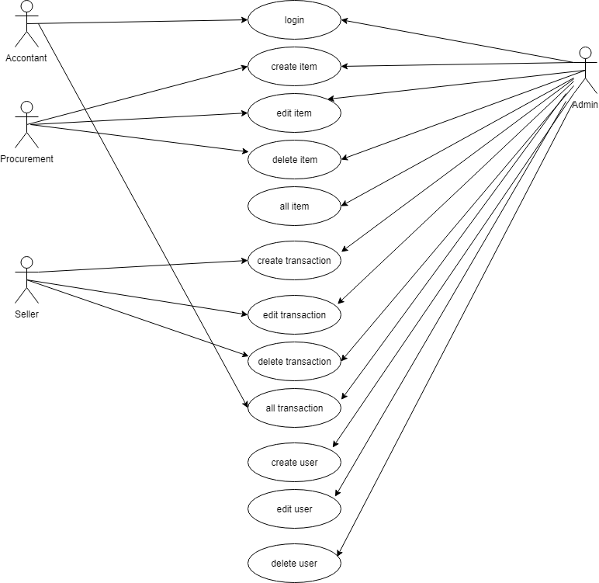

Figure 2: Use Case Diagram

## 4.4

## 4.5 ER Diagram

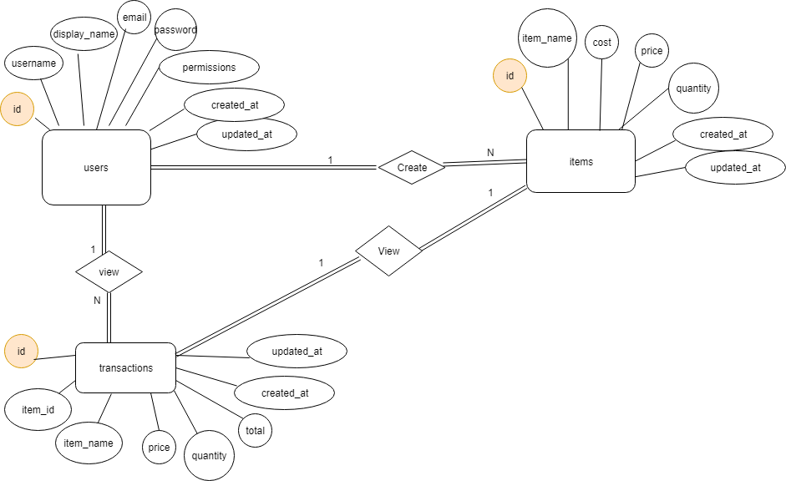

Figure 3: ER Diagram

# Chapter 5: Experiments and results

## 5.1 Overview

In this chapter, we will talk about how we test the system with the intent to find whether it satisfies the specified requirement or not.

### 5.2.1 Unit Testing.

Three types of units are included, the first for the **Login Page**, the second for the **Create items**, and the third for the **Admin portal**.

#### 5.2.1.1 Login Page

It was checked that the data entered in the registration form was saved in Database, and to ensure that the registration and entry laws are applied to the system.

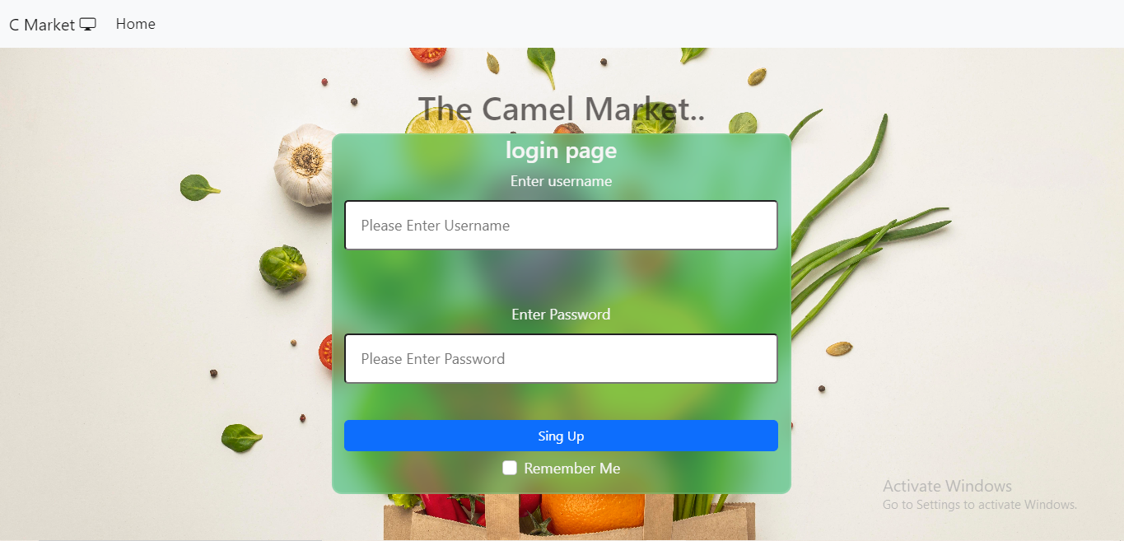

Figure4: Log in page

#### 5.2.1.2 Create items

1. Create item

This page works to create a new item and add it in the data base and display it on the all item page.

Figure 5: Create item page

1. All Items

This page displays all items that have been created and can be deleted or modified.

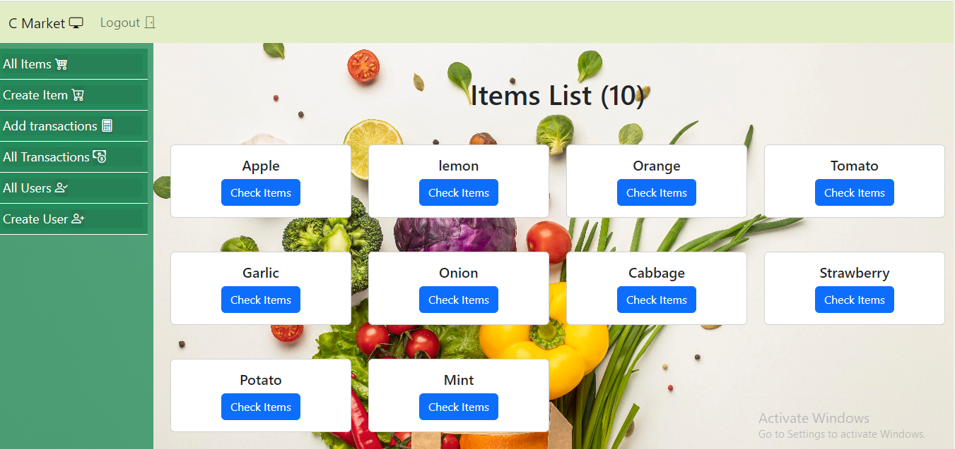

Figure6: All items page

1. Edit Item

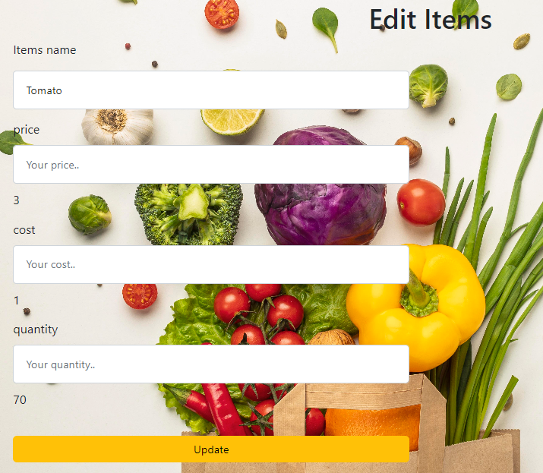

Figure 7: Update Item page

#### 5.2.1.3 Admin portal

1. Dashbord

See the admin dashbord page.

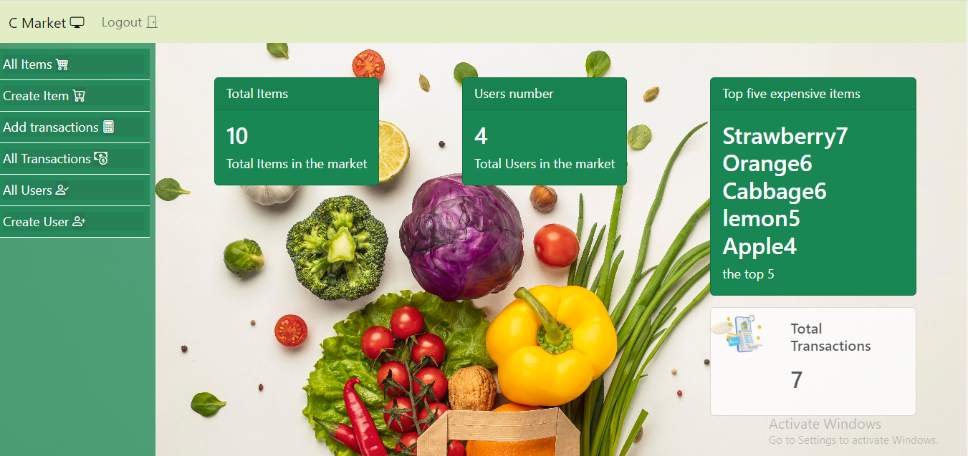

Figure8: Dashbord page

1. Create tranaction

Create any transaction through this page.

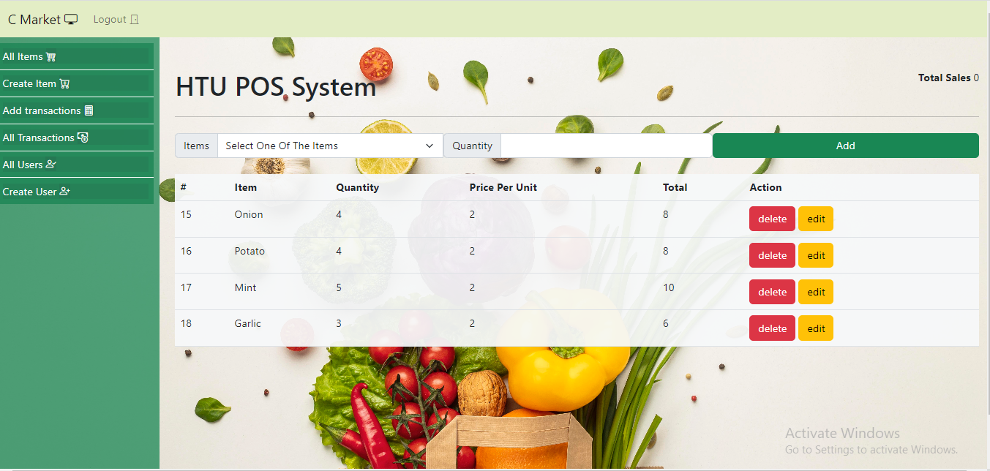

Figure9: Create transaction page

## 5.4 System results

After checking all stages of the test, the system is functional and correct.

# Chapter 6: Conclusion

## 6.1 Conclusion

## All stages of the system have been created for the POS, and the required goals reached.

## 6.2 Future Work

* Provide another language.
* Convert it to an Android and iOS application.

# REFERENCES

1. <https://www.w3schools.com/>

To use some code for design and some programming issues

1. <https://stackoverflow.com/>

To come up with some solutions to the problems we were facing

1. https://www.javatpoint.com/software-engineering-incremental-model

The site from which we derived the study strategy

[4] <http://developer.mozilla.org>

Use site to change tag properties in html

[8] <http://githup.com>

This site was used to see some projects and learn from them.